## downloadGarbage Collection

In the capital city Soppia of the kingdom of Bulgar Istan, garbage collection has always been a problem. The reigning king of Bulgar Istan, his Majesty Pesho I, has hired 2 well-known garbage collection companies(**“Titan”** and **“Wolf”**). They have negotiated to distribute the garbage collection in the different districts among themselves according to the rules below:

* **Rule 1:** Because the garbage trucks require a special fuel called “nafta”(and both companies need to save as much fuel as possible), they agreed to operate only in districts in which they can collect all the garbage by driving down each street only once
* **Rule 2:** **Wolf** takes all districts, where a truck can collect all the garbage without violating **Rule 1** and exit **the same way it entered**
* **Rule 3:** **Titan** takes all districts which satisfy the condition in **Rule 1** and are not taken by **Wolf**
* **Rule 4:** All remaining districts stay **Dirty**

Example with 3 districts:

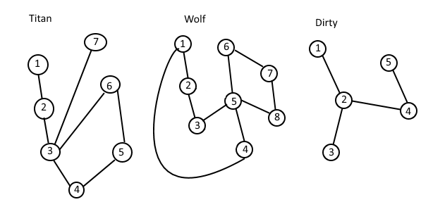

Explanation:

* **Wolf** takes the second district, because they can collect the garbage in the following order: **1,2,3,5,6,7,8,5,4,1** – driving down each street exactly once and leaving the district from the same place they entered
* **Titan** takes the first district, because the garbage can be collected in the order **1,2,3,4,5,6,3,7** by driving down each street exactly once, but the district doesn’t satisfy **Wolf**’s conditions
* The garbage in the third district cannot be collected by passing each street exactly once, therefore neither **Titan** nor **Wolf** want to operate there(“nafta” is very expensive)

### Input

The input data should be read from the console.

On the first line there will be the number of districts - **N**.

Next, you will receive **N** districts, which will be provided in the following format:

The first line will be “**NAME X Y”** where **NAME** is the name of the district, **X** is the number of crossings in the district and **Y** is the number of streets in the district. On each of the next **Y** lines there will be a street in the format “**S E”**, where **S** is the one end of the street and **E** is the other end(**S** and **E** are crossings).

The input data will always be valid and in the format described. There is no need to check it explicitly.

### Output

The output data should be printed on the console.

For every district, you should print the following: “**D C”,** where **D** is the name of the district and **C** is the name of the company that agrees to operate in the district with name **D**. If no company agrees to operate in **D**, print **Dirty** in place of **C.**

### Constraints

* 1 < **N** < 300
* 2 < **X** < 2000
* **X** / 2 < **Y** < 4 * **X**
* There won’t be unreachable parts in any district.
* All streets in the districts are two-way streets.
* Allowed working time for your program: 0.5 seconds. Allowed memory: 16 MB.

### Examples

|  |  |  |  |
| --- | --- | --- | --- |
| **Example input** | **Example output** | **Example input** | **Example output** |
| 2  Drujba 7 7  1 2  2 3  3 4  3 7  4 5  5 6  6 3  Orlandovci 8 9  1 2  2 3  3 5  5 4  4 1  5 8  5 6  7 8  7 6 | Drujba Titan  Orlandovci Wolf | 3  Mlados 5 4  4 5  1 2  2 3  2 4  Drujba 5 5  4 5  1 2  2 3  2 4  5 3  Lulin 3 3  1 2  2 3  3 1 | Mlados Dirty  Drujba Titan  Lulin Wolf |
| 1  Narnia 5 5  1 3  1 4  2 4  2 5  3 5 | Narnia Wolf | 1  Levski 7 10  1 2  1 3  2 3  2 4  1 4  4 5  1 7  5 7  5 6  7 6 | Levski Dirty |